**How To Launch a RDS Instance In a Specific Subnet**

Let’s launch a Postgres RDS in AWS. You will get 750 hours of Amazone RDS Single-AZ db.t2.micro instance as part of [12 month free tier](https://aws.amazon.com/rds/free/). You also have a bit of options (MySQL, MariaDB, or SQL Server). I am choosing Postgres here.

Amazon RDS makes it easy to set up and maintain a relational database. A few clicks of the button, you will have a fully working database. How awesome!

This is one of the steps in [**How To Create Your Personal Data Science Computing Environment In AWS**](https://www.mydatahack.com/how-to-create-your-personal-data-science-computing-environment-in-aws).

According to my plan, I want to have Postgres in Subnet B from AZ2. Let’s get started.

**Steps**

1. **Go to RDS dashboard and click Get Started Now.**
2. **Choose PostgreSQL**

Tick ‘Only enable options eligible for RDS Free Usage Tier’ if you are still eligible for free tier. If you choose free tier, Multi-AZ option is not available.

1. **Set user name and password**
2. **Configure advanced settings**

Choose VPC and right availability zone. Once you choose the right availability zone 2, the database will be in the Subnet B according to our plan. Make sure to attach the security group we created previously.

Make sure the instance is publicly accessible.

Add database name. I named it as mydatahack. Keep the default port of 5432.

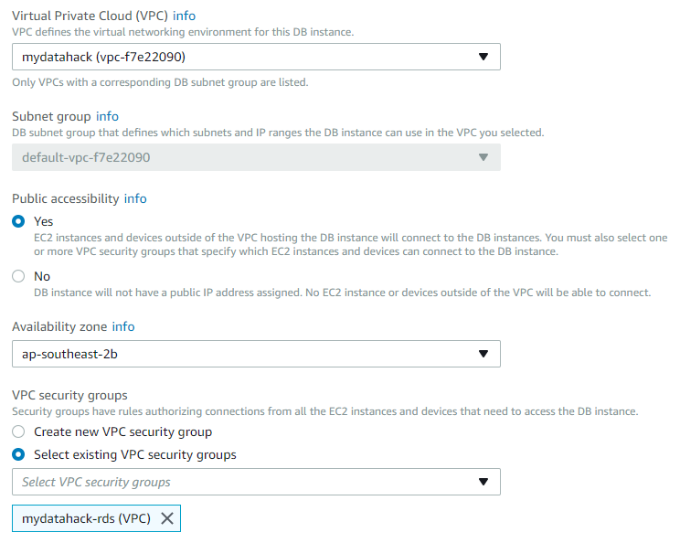

1. **Connect to Postgres from your desktop.**

Grab endpoint from the RDS dashboard and set up connection in your SQL client. I use pgAdmin as a client.

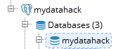

1. **Set up users and schemas**

Now you can set up users and schemas. Check out the entry here: [**How To Create User Credentials And Grant Privileges In Postgres**](https://www.mydatahack.com/how-to-create-user-credentials-and-grant-privileges-in-postgres).

We now have a working Postgres RDS.

Let’s go back to <strong><a href="https://www.mydatahack.com/how-to-create-your-personal-data-science-computing-environment-in-aws" target="_blank">How To Create Your Personal Data Science Computing Environment In AWS</a></strong> to complete the rest of the steps! You are almost there!